**DAILY ONLINE ACTIVITIES SUMMARY**

|  |  |  |  |  |  |  |  |
| --- | --- | --- | --- | --- | --- | --- | --- |
| **Date:** | **2/06/2020** | | | | **Name:** | **Samrin Banu** | |
| **Sem & Sec** | **8th B** | | | | **USN:** | **4AL16CS082** | |
| Online Test Summary | | | | | | | |
| **Subject** | | **--** | | | | | |
| **Max. Marks** | | **--** | | **Score** | | **--** | |
| Certification Course Summary | | | | | | | |
| **Course** | **Step into Robotic Process Automation** | | | | | | |
| **Certificate Provider** | | | **Guvi** | **Duration** | | | **3 hrs** |
| Coding Challenges | | | | | | | |
| **Problem Statement:**  **1) c++ program to find sum of digits until the number in a single digits** | | | | | | | |
| **Status: Solved** | | | | | | | |
| **Uploaded the report in Github** | | | | **YES** | | | |
| **If yes Repository name** | | | | **Samrinbanu** | | | |
| **Uploaded the report in slack** | | | | **YES** | | | |

**Certification Course Details:**

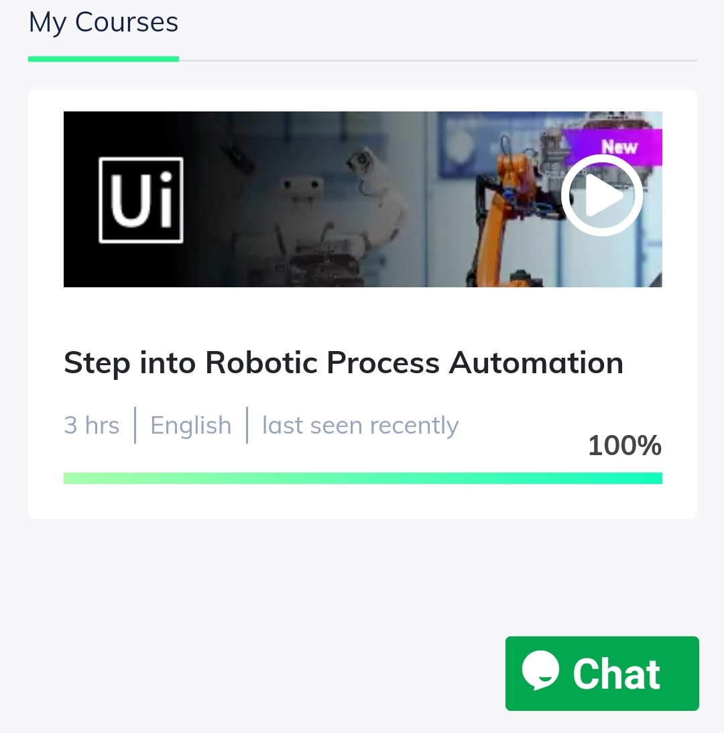

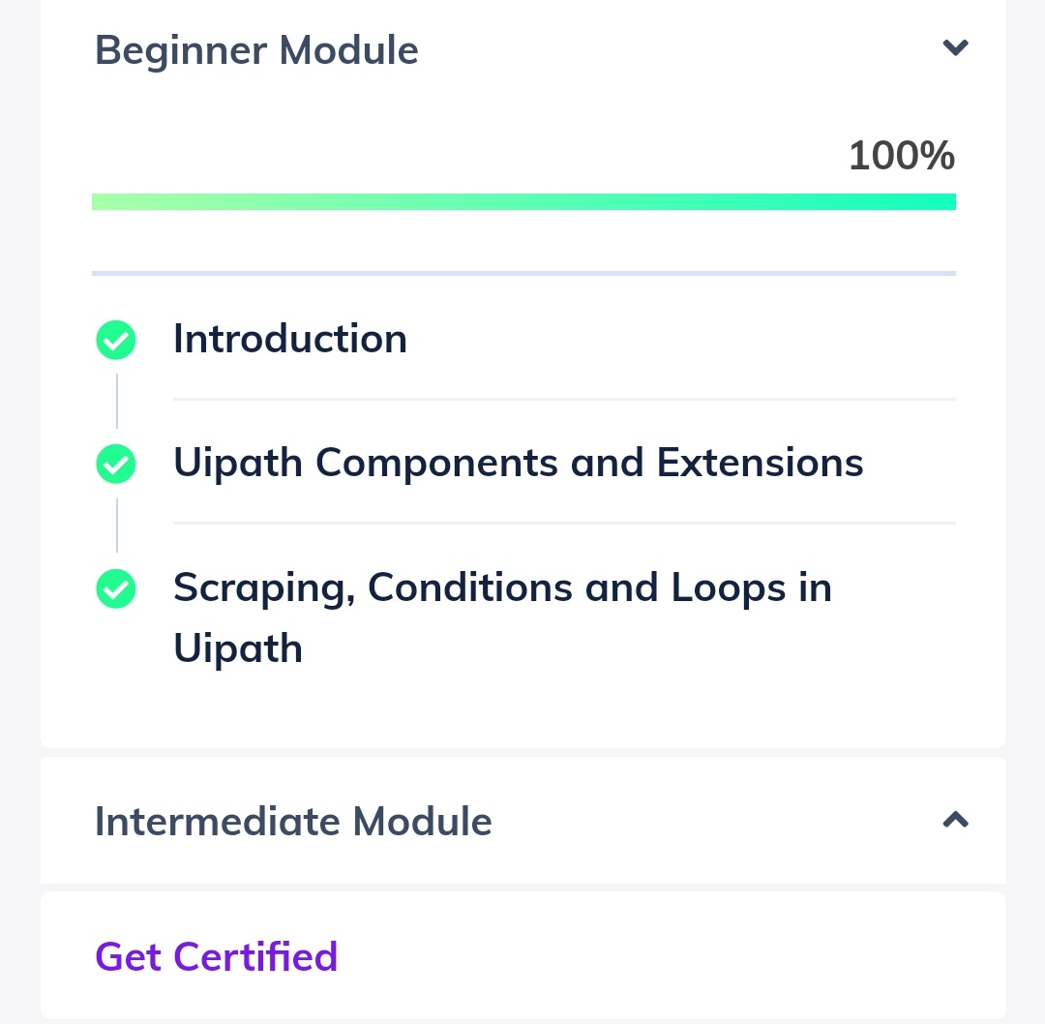

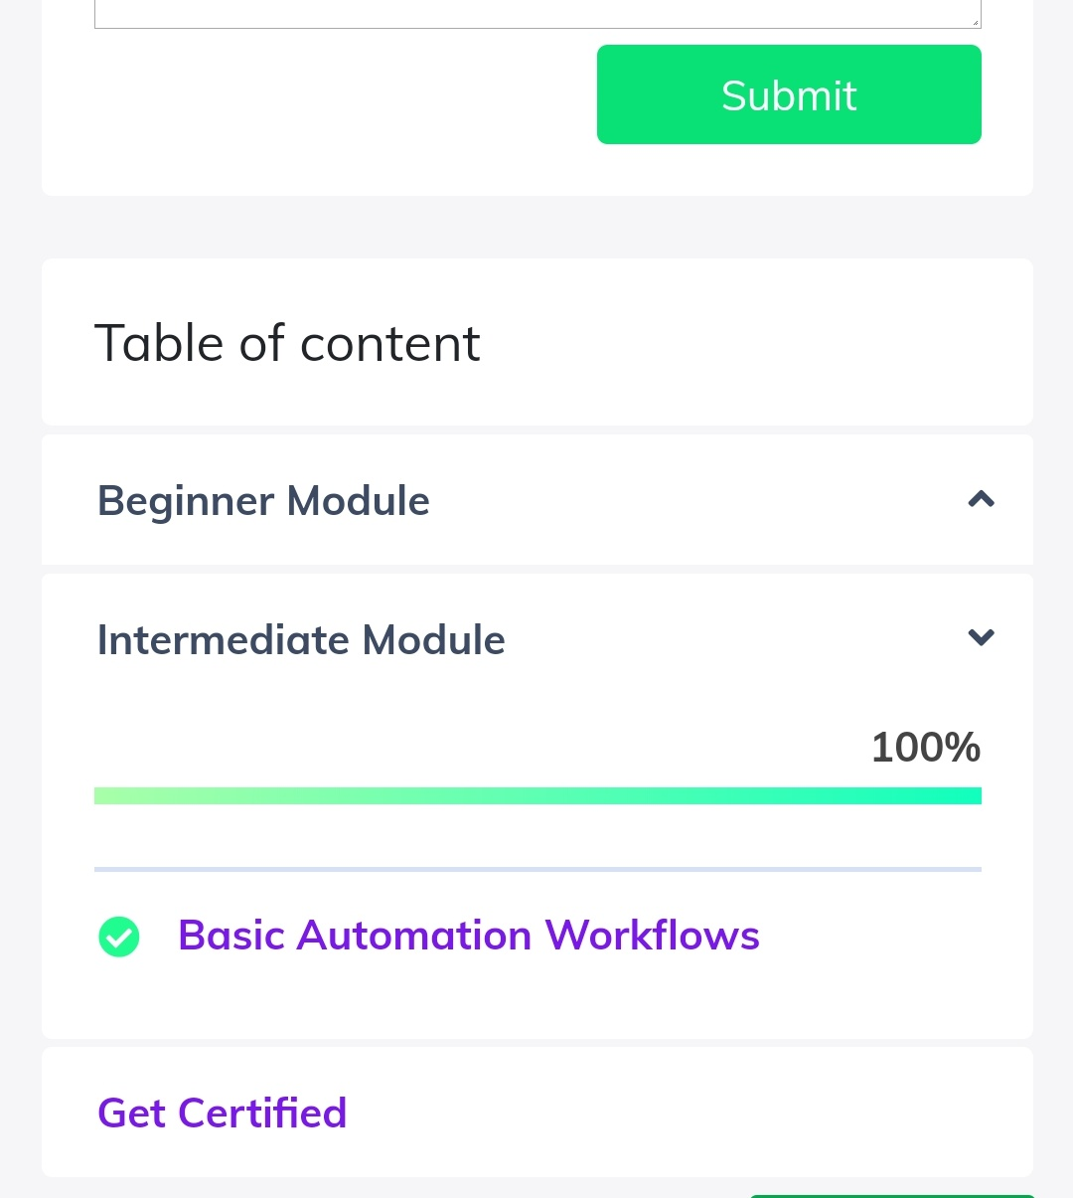

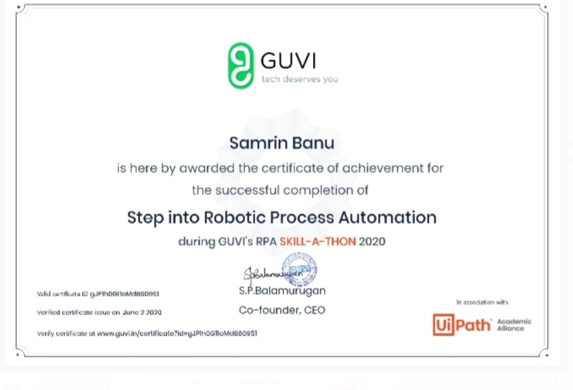

# CODE:

Program no:1

###c++ program to find sum of digits until the number in a single digits###

#include

<iostream>using

namespace std;

int main()

{

int number=147;//Any

number.int res;

if(number)

res=number % 9 = = 0 ? 9 : number % 9;

else

res=0;

//printthe

result

cout<<res;

return0;

}